Melinda Fidler
Phil 1250 T/R 1 pm class
Signature assignment

Identifying the Issue:
The article chosen is titled Nigeria’s Stolen Girls and talks about the ongoing issue with Nigeria’s 276 missing girls, kidnapped by the Boko Haram Islamist group.
The issue stated for this article asks: “Can the Nigerian government protect its people without U.S. support?” The conclusion to this is no, Nigeria’s government cannot protect its people and needs the help President Obama offered.
The burden of proof is put forth to the reader, to convince this audience that the Nigerian government is corrupt, inept and uncaring for its people, and that it does in fact need aid from the U.S.
The premises for this argument are: (1) The Nigerian Government is slow at addressing problem, and (2) the government cannot contain virulent insurgency
There are several sub premises for these arguments. For premise 1-the Nigerian government is slow to address problems the sub premises are: (a) three weeks after 200 girls were abducted, 276 are still missing, (b) after weeks of silence on the issue, President Goodluck Jonathan admitted that it is a “trying time for the country, and (c) two weeks after the kidnapping the president finally called a meeting to discuss the incident.
The sub premises for premise 2—the government cannot contain virulent insurgency are: (a) until now, there has been little response to insurgent violence, (b) the Islamist group Boko Hama seeks to destabilize and overthrow the government (c) violence by the Islamist group has gone on for over 5 years, (d) Nigerian forces have been unable to defeat the Islamist group, (e) the security situation in Northeast Nigeria has steadily deteriorated and (f) the kidnapping of the girls is not the first incident to happen—the Boko Hama has attacked students before.
These premises and sub premises are all relevant to the issue that Nigeria cannot protect its people because it will cannot or will not do so, but are all irrelevant to whether or not the United States should “step in” as there is only one sentence offering support for that claim.

Diagramming the Argument:
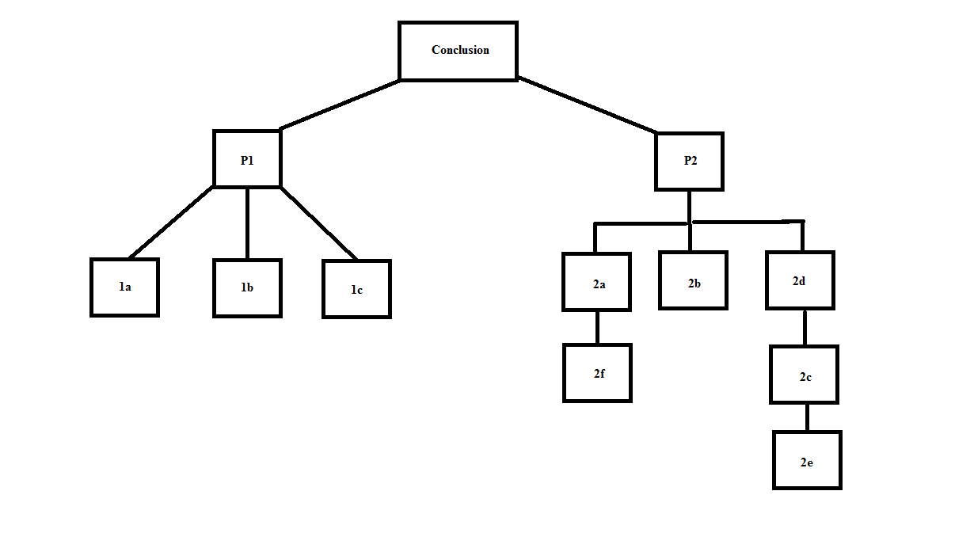

Fallacy Response:

The United States should not get involved with other countries’ problems because once they do, then more countries will require help, which will lead to a specific reliance on the U.S. in general and will lead to anarchy because no country will be able to ever do anything without the say so of the United States, which will make the United States a fascist government. And only a leader like Hitler would allow such a thing to happen. Besides, getting involved goes against the social and cultural norms of the American people, who traditionally support an isolationist political view. Also, the economy of the U.S. is too unstable for its government to be offering aid to other countries, and would likely cause internal problems.
According to Dr. Samuel Burundi of the Art History Institute in Cleveland, Ohio, the problems in Nigeria are not caused by government corruption or social structure, but are caused from the overzealous media within the region. So, this is why involvement of the U.S. would also fail to help the problem.
Fair Response:
This author presented a look into the problems that are going on within Nigeria, and how, due to lack of governmental control and response, the country is failing the people that it is supposed to protect. Because of this, several crimes against the people have occurred at the hands of the Islamist insurgent group Boko Hama, who have recently kidnapped 300 girls. Because of the lack of governmental involvement, the girls have not been returned and the United States has offered intelligence and investigative aid, which, according to the author, the Nigerians highly need and should take.
I found the information the author used to be insightful. The author had good points to show corruption and neglect by the government, and also had well written information on the Islamist group that continues to attack the Nigerian people. The article was also designed I think, to garner an emotional response from the reader, which it did, as I felt sorry and angry about the crimes against children going on with in Nigeria’s borders.
There are only a few aspects I do not agree with in this article, such as the necessity of the United States to be involved. While it is true that the United States has the resources to assist, until involvement is absolutely necessary, it should be handled by the U.N. who should also have resources matching those of the U.S. I also do not agree with the wording in the article, for all crimes are “monstrous” and all radical groups that commit them are “ruthless”. The first part of the article was a little like reading a novel and not an argument, the words only detracted from what was being said, not adding to it. It’s use while attempting to elicit feelings of anger and sadness-which only the facts were able to do-these words elicited a feeling of annoyance and reminded me of historical articles of propaganda.
I agree with what the author of this article is saying, that there is a problem with the Nigerian Government and that it is overlooking crimes because of corruption, however I don’t believe that these crimes can be called shocking as it is apparent that they have been long ignored by the Nigerian Government, nor are they ones isolated to Nigeria alone. In other countries where the culture is dictated by certain belief systems such as Saudi Arabia, Afghanistan and India, there have been several cases of groups attacking women for “Western thinking” or for those who seem to be going against the cultural and social norms. I also believe that the problem is an international one that the United Nations should be involved in. The problem of slave and sex trafficking is an international one and this is why it is necessary to examine and investigate the kidnapping of the female students as the leader of the Boko Hama has admitted/threatened to sell the girls into this trafficking. The United States, while being fair and “politic” in offering help to Nigeria, is not specifically “needed”. The U.S. if, getting involved, should not be the only country to do so, as again, the problem should be of international interest and as many nations see the United States as “meddlers” any aid would likely be seen as such, which may cause other insurgent problems where the U.S. currently is “meddling:.

Reflection:

I believe that my counter argument is fairly strong, as I attempted to take an unbiased view of the facts that were presented, and did not use a form with words that could be seen as being propaganda-esque. I believe that I could have used more premises to support my conclusion on the issue as well as make a stronger case for the conclusion. I also believe that more research is needed on the subject as I am not as familiar with the topic.
I believe there was good logical flow to my argument as I made the points and showed facts within the supporting premises. However, I am sure that my argument needs a lot of work with addition of more premises to support the conclusion.
If I were to analyze my own argument I would say that I need to focus on more premises and setting up my argument better. I believe that research is also needed to support my premises. Perhaps it would be necessary to add to the argument in other ways, such as creating a diagram before hand to make sure it could stand on its own.

List of Fallacies Used:

- Slippery Slope
- Appeal to tradition
- Reductio ad Hitlerum
- Appeal to tradition
- Red Herring
- False appeal to authority 1st condition

